ECE 301 Digital Electronics
LAB TIPS
Revised Fall 2013
K. Hintz & C. Lorie
- Tutorials and equipment manuals for the laboratory equipment are available on-line at
http://ece.gmu.edu/tutorials-and-lab-manuals.
- Twenty-two gauge wire (22AWG) is the best size to use with the trainers and solderless breadboards.
- Solid wire only, never stranded, is used for the trainers.
- Keep jumper wires short. Strive for a neat and logical layout. This will make troubleshooting easier and successful circuits more likely.
- Using more than one color of wire will help you debug your circuits. Normally RED and BLACK are reserved for power and ground.
- Most of the chips which are used in the lab are not overly static sensitive, however, you should observe some precautions when handling them, particularly in the dry cold of winter when the humidity is low. It is best to touch a ground before handling chips not enclosed in a static protective material. For electrostatic sensitive chips, a high impedance wrist strap connected to ground. This should not be necessary for TTL chips.
- If you were issued a tube, it protects the chips from static charges, and is sturdy enough to provide protection to the delicate, metal pin legs.
- Keep your chips away from magnets, motors and high temperatures.
- Don't leave semiconductor electronic components in your car in the sun or extreme cold. They do best in the moderate temperatures most humans prefer.
- Bent pins may be gently straightened with fingernails or a needlenose pliers. If the pins break, you will need to purchase a new IC.
- A small, narrow-blade, flathead screwdriver is useful in removing chips from breadboards. Using a side-to-side rocking motion as you insert the blade under the chip, keep a finger lightly on top of the chip to prevent it suddenly popping up on one end, bending the pins.
- Chip leads are slightly flared to help hold them in printed circuit boards while being soldered. You will need to reduce the flare to allow them to be inserted into the breadboard. Use a pair of needlenose pliers or press the leads against a table top while rotating the body of the chip towards the lead points to reduce the lead angle of all evenly. Don't bend too far; there is no easy correction.
- To locate pin 1 on an integrated circuit {IC, chip), look for one of the following:
* A semicircle at one end, often cut into the end of the chip - With this at the top, pin 1 is at the left of the half circle. Sometimes, there is one whole circle.
* A tiny spot in the corner of the chip beside pin 1. There may or may not be other marks on the chip.
When looking at the chip from the top, as when it is in a breadboard, count pins from pin 1 CCW (anticlockwise) around the chip so that the last pin is straight across from pin 1 and at the same end of the chip. Common chip sizes are 8 pin, 14, 16, 18, 20, 24, 28, and 40 pin. Your TTL ICs (Transistor-Transistor Logic Integrated Circuits) will be in dual inline packages (DIP).
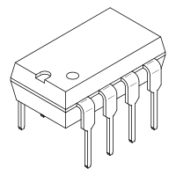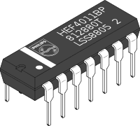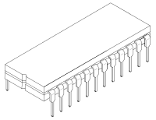
8 1,2,3,4 14 1,2, ... ,7 24 1, 2, ... , 12

BREADBOARD

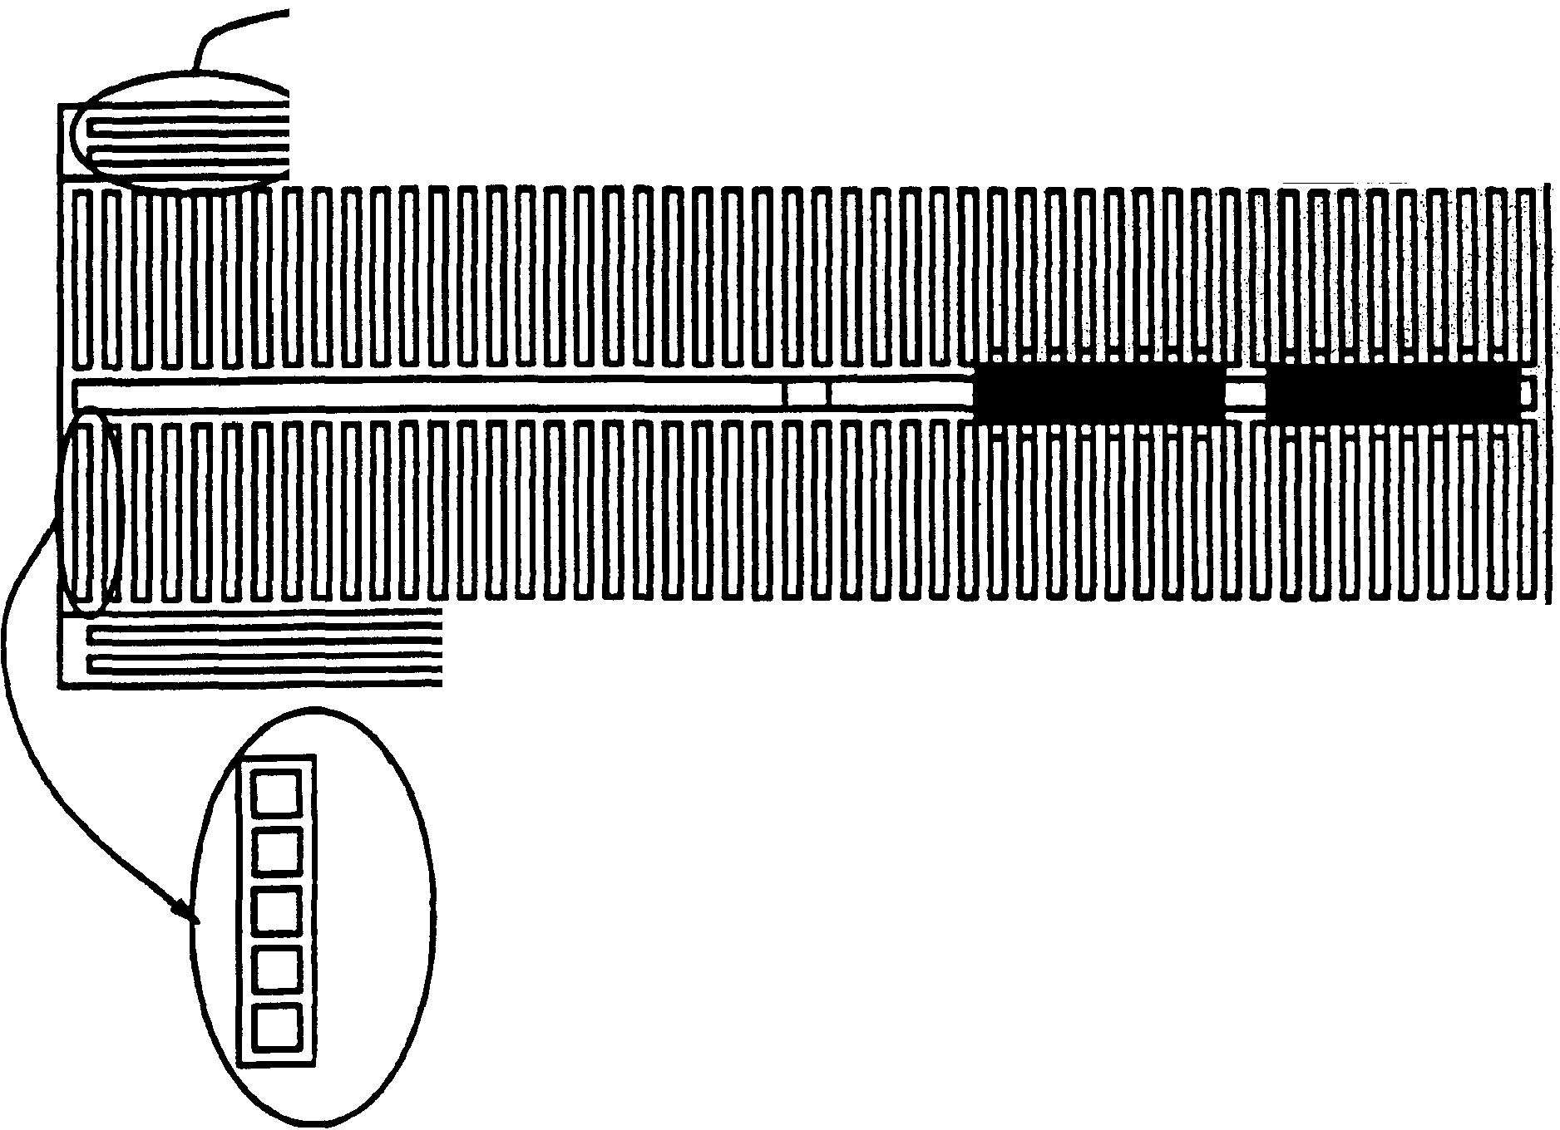


Horizontal rows are connected as single node.
Each vertical group of 5 holes is connected to a single node.

